Smart Accident Response System: Non-GPS Location and Nearby Hospital Detection with Medical Record Transmission

Snahal Kumar¹, Somya Sinha¹, Sumeet Gupta¹, Sachin Kumar Gupta^{1,2}
¹School of Electronics and Communication Engineering,
Shri Mata Vaishno Devi University, Kakryal-182320, Katra, (UT of J&K), UT, India
²Department of Electronics and Communication Engineering,
Central University of Jammu, Samba-181143, Jammu, (UT of J&K), India.
snahal135@gmail.com, somyamgr28@gmail.com, sumeet.gupta@smvdu.ac.in, sachin.ece@cujammu.ac.in

Abstract: This paper introduces a smart accident response system designed to address limitations in conventional emergency medical services for vehicular accidents. Unlike previous systems relying on Global Positioning System (GPS) modules and their antenna, this device uses non GPS Google Geo-location methods for instant accident location identification. It locates the three nearest hospitals within a 5 km radius and automatically emails the medical records of victims and directions to the accident site to both healthcare provider and family members in less than 2 minute. By overcoming challenges related to location inaccuracy, especially in urban canyons or areas with poor satellite visibility, delayed medical information and unavailability of onsite medical records during rescue operations, and communication inefficiencies with family members and doctors, our smart accident response device integrates with current autonomous vehicle aims to improve emergency medical responses, leading to improved patient outcomes in critical situations.
Index Terms: vehicle accident, Geo-location, Geo-places, medical records, SMTP, esp8266, Google Maps, spreadsheet, emergency response.
I. Introduction
Around 20-50 million people get non-fatal injuries in road accidents each year, which claim the lives of about 1.3 million people worldwide [1]. Based on estimated global road traffic fatalities 29% of all road traffic deaths are car occupants and 28% are motorized 2 wheeler or 3 wheeler [2]. In the year 2021, there were 4,12,432 recorded road accidents in India, resulting in 3,84,448 injuries and 1,53,972 fatalities. However, 18 to 45 is the age group most severely affected by car crashes, and this age group accounts for over 67% of all accidental deaths [3]. As per the recent report the problem is particularly acute in India, where road infrastructure is a complex network of National Highways (NH), State Highways (SH), and Other Roads. In 2023, this network witnessed 4,80,583 recorded accidents, resulting in 1,72,890 fatalities and a significant number of injuries which is increased by 4.17% [26]. While some regions are making progress. For instance, the United States saw a 4.3% decrease in traffic fatalities in 2023, with 40,901 deaths, alongside a 6.0% reduction in the fatality rate per 100 million vehicle miles traveled but estimated number of people got injured in 2023 increased by 59,748 to 2.44 million, a 2.5% increase from the 2.38 million people got injured in 2022 [27]. Efficient emergency response is important in reducing the impact of traffic accidents on human lives. The importance of minimizing the duration between an accident and the arrival of emergency respondent, particularly those equipped with prior information about the victim’s medical history, allergies, and age. Such response strategies not only contribute to the prevention of traffic fatalities but also facilitate the provision of immediate and tailored medical services onsite.

Table 1: Accident by Category of Roads in India [26] - Data Source, Ministry of Road Transport and Highways Transport Research
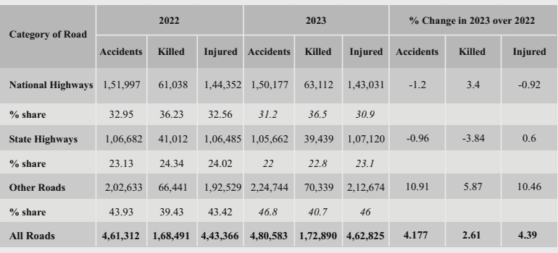

Table 2: Accident Reported in United States [27] - Data Source, FARS 2022 Final File, 2023 ARF. CRSS 2022-2023
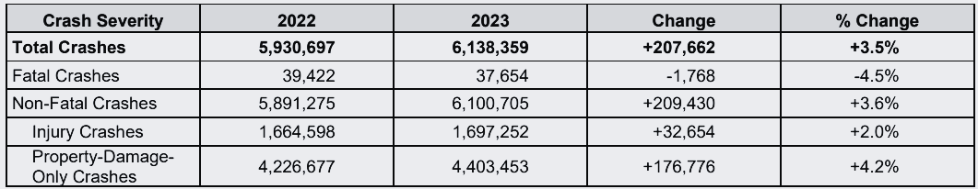
The State and Union Police Departments have recorded a total of 4,61,312 traffic incidents during the 2022 calendar year, claimed 1,68,491 lives and 4,43,366 injuries in India [3] and 1,664,598 injuries in United States [27] while in 2023 this numbers is increased. The motivation behind this research is driven by the challenges faced by individuals or family members involved in vehicular accidents. Issues such as lack of location awareness, delayed medical assistance and communication hurdles underscore the critical need for an intelligent emergency response system.
Modern technologies and researchers utilize GPS, GSM, GNSS, or GPRS based techniques to retrieve the current location and send messages [4]. As this module determines the present location, the antennas present in the modules are utilized to establish a connection with GPS satellites and gather coordinates through a low profile, GPS circular polarization patch antenna [4], [5], [6]. This method is not practically possible as communication through satellite would not work effectively due to environmental factors like weak signal strength in remote areas or bad weather hampers accuracy, insufficient satellite visibility affects the precision of coordinates as detailed in further section.
This research is committed to comprehensively addressing these challenges. The primary objective is to introduce a low cost affordable small sized device using advanced and latest Google Cloud services to perform all the necessary task for free without the need for additional hardware like other IoT devices required [19]. The goal is to provide a quick, seamless and tailored response to vehicular accidents in less than 2 minute, with aspirations of further reducing this to 30 seconds through continuous improvement and additional studies.
The rest of the article is organized as follow: introduction section provides background information on the limitations of conventional emergency medical services for vehicular accidents. It introduces the smart accident response system, emphasizing its reliance on non GPS Google Geo-location methods and integration with the Google Geo-places API. Section 2 reviews existing technologies and solutions for emergency response systems, highlighting limitations in traditional systems, GPS based location systems, mobile health applications, and hospital navigation systems. Further, section 3 addressing gaps with the proposed device. The paper details the features of the smart accident response system, including automated identification and medical history retrieval, GPS free location determination, realtime hospital information retrieval, and automated communication. Next is the methodology section outlines the hardware components and connectivity, such as the integration of the esp8266. As it explains the Geo-location method using nearby cell towers or access points, the structure and purpose of excel sheets, and the HTTPS requests for information retrieval and storage. It covers the Email communication process using SMTP. Then further sections are the results, implementations and discussions: this section presents the flow chart of the device working, testing, and simulation phases. It discusses real world deployment considerations and the potential implications of the proposed device, the future roadmaps section suggests opportunities for refinement and enhancement, including enhanced medical record security, machine learning integration, user interface development for emergency responders, and public awareness campaigns. Finally, the conclusion summarizes the key findings and contributions of the research, emphasizing the transformative potential of the smart accident response system in the field of emergency response systems.
II. Literature review
The field of emergency response systems has witnessed major advancements in recent years, with multiple solutions aiming to address the challenges associated with effective assistance during vehicle accidents. This section reviews existing technologies and solutions, with their limitations.
Table 3: A comparative summary of the different techniques in use.

Reference | Technology/Methodology | Limitation
M. Syedul et al.  (2012) | GPS for location and GPRS, GSM to send text messages. | External Antenna for GPS and additional SIM card is required.
Baode Li et al.  (2023) | Machine learning algorithms decision tree, classification and regression tree and random forest. | For more accurate prediction, it requires more data models (trees) that results in a slower model.
S. Karthik. et al.  (2023) | GPS for location and RF transceiver for communication with hospitals. | Need large antenna and more power for longer distance transmission.
H. Srivastava et al.  (2022) | Used MPU9250, 9 DoF, MEMS, IMU, Arduino nano, esp8266 and GPS. | Very high cost as the whole process can be done using esp8266 only.
M. Almomani et al.  (2011) | GPS, GPRS and GSM | High power consumption due to different module and different antenna for GPS and GSM.
Bhandare, Sujit N (2025) | GPS, GSM, IoT, ESP32, VANET, Firebase, MQTT | GSM communication requires a SIM card, making it impractical for large scale deployment due to recurring maintenance and monthly subscription costs.
- Traditional emergency response systems:
- Traditional systems relying on phone calls face limitations when individuals are incapacitated or unable to dial phone numbers to make calls.
- Possibly the people around the victim are not helping because of fear and just ignoring it, also known as the Bystander effect [7], [9].
- Some researchers propose traffic emergency response systems using data mining and the IoTs for quick and accurate control [8].
- GPS based location systems:
Several solutions uses GPS technology to determine the location of an accident [4], [5]. but, these systems has major drawbacks as direct lines of sight to satellites are frequently obstructed, leading to a weak or lost GPS fix. This is critically common in scenarios such as:
- Under tunnels and underpasses there is complete signal loss, rendering GPS navigation useless until the vehicle exits.
- Overpasses and closely spaced high rise buildings create a 'roof' that blocks some portion of the sky, limiting the number of satellites the receiver can 'see'. Signals bounce off buildings, creating a longer path to the receiver and distorting the calculated position.
- Heavy tree canopies, especially when wet, can attenuate and scatter the relatively weak GPS signals.
- Inside indoor parking garages GPS signals cannot penetrate the multiple layers of concrete and steel, making location tracking impossible.
- Underground or semi underground roadways similar to tunnels, these structures completely isolate the vehicle from satellite signals.
- Mobile health (mHealth) applications:
Mobile health applications offer features like storing medical information and sharing location data [10]. These solutions may rely heavily on user input, which can be challenging in emergencies, especially when individuals are unable to interact with their devices.
- Hospital navigation systems:
- Some systems lack realtime accident data, leading to delays in emergency response.
- Misdirection to hospitals ill-equipped for specific medical needs is a potential consequence.
- Ambulances may struggle to promptly locate accident sites.
- Lack of awareness about victim details (for example age, blood type, allergies) hinders effective emergency response.
Survey findings emphasize the critical nature of communication in emergencies. Efficient communication of accident site details and victim requirements can’t be ignored [11].

Table 4: A Comparative Analysis Highlighting Novelty of Proposed System

Limitation in Existing Systems | Proposed device’s Approach | Practical Impact
Susceptible to signal attenuation, multipath error in urban canyons, and slow Time To First Fix (TTFF). | Utilize Cloud Services which uses a probabilistic model based on MAC addresses of nearby Wi-Fi APs and Cell Tower IDs with signal strength (RSSI) to triangulate position. | Achieves faster location fix and superior accuracy in GPS denied environments by leveraging dense urban infrastructure. Reduces location error from ~10-20m (typical GPS) to <2-4m (Wi-Fi/Cellular).
Discrete components (GPS receiver, GSM modem, MCU) increase system cost, power budget, and points of failure. | Uses ESP8266's integrated Tensilica L106 core, Wi-Fi transceiver, and GPIOs for a monolithic hardware architecture. | Eliminates discrete ICs. Lowers power consumption to ~80mA during active transmission vs. >150mA for multi module systems. This not only enhances system reliability but also improves power efficiency, contributing to a more environmentally sustainable solution.
Transmits basic SMS/coordinates, lacking contextual data for triage and prehospital care. | Implements a unique ID based query system to fetch structured Electronic Health Record (EHR) data from a cloud repository, fusing it with realtime incident data. | Provides a structured data payload (allergies, medications, conditions) that allows for data driven decision making before EMS arrival, addressing the "golden hour" criticality.
Reliance on SMS or custom RF links restricts interoperability and data scalability. while also incurring additional costs associated with SMS charges and SIM card maintenance. | Utilizes HTTPS for secure data transport and SMTP with MIME for rich email alerts, ensuring compatibility with universal internet infrastructure. | Make use of existing cloud infrastructure. Supports hyperlinks, HTML content, and attachments, enabling direct access to live maps and medical records, which is impossible via SMS.
Family notification is often secondary or non existent. | Automates targeted SMTP alerts with role-based information full medical context for hospitals, location/status for families, and a unified live data link for all. | Creates a shared situational awareness platform, reducing panic and misinformation among family members and medical authorities.

Table 5: Comparison of Proposed Device with Apple's Crash Detection & Satellite SOS. [28] [29]
Feature / Characteristic | Apple Crash Detection & Satellite SOS | Proposed Smart Accident Response System | Advantage of Proposed Device
Core Paradigm | Personal Device Centric | Vehicle-Embedded & Collective | Provides a safety net for all occupants, independent of personal device status.
Multi-Occupant Identification | No | Yes (via Wi-Fi hotspot scanning) | Automatically identifies and retrieves data for all registered passengers in the vehicle.
Medical Data Transmission | Manual Medical ID setup required, shares data for device owner only. | Automatic retrieval & transmission of EHR for all identified occupants. | Ensures emergency responders receive complete medical History for every victim immediately.
Family/Emergency Contact Notification | Notifies contacts after emergency services, requires iOS 16.1+ for full features. | Simultaneous, automated alerts to families & hospitals with full context. | Creates immediate shared situational awareness, reducing panic and misinformation.
Location Method | GPS (primary), Satellite fallback | GPS free Google API (Wi-Fi & Cell Tower triangulation) | Faster location speed and accuracy in urban canyons where GPS fails.
Off-Grid Capability | Yes (via Satellite, Available in specific region only) Requires clear view of sky and horizon challenging in urban canyons, tunnels, or vehicle wreckage. | No (requires cellular data) | Apple's key strength in remote areas without cellular coverage.
Cost & Accessibility | High-cost, premium Apple devices only. | Low-cost (~$2-4 BOM), universal and affordability | Economically viable for mass deployment across all vehicle segments and demographics.

This device’s low cost is crucial for India. At just $2-4 to make (roughly ₹165-330), it is incredibly affordable than iPhone for SOS Service. Our solution isn't just smarter with data, it's designed to be within financial reach for almost everyone, making life-saving technology accessible to the masses.

III. Addressing gaps with the proposed device
The device presented in this paper stands out as a low weight, cost effective, small sized solution that bridges these identified gaps and can handle 6000 accidents across the globe per minute for free.
- Automated identification and medical history retrieval:
By using the esp8266 hardware and connecting to smart phone hotspots, the device can automatically identify individual inside the vehicle and retrieve their medical history stored on a dedicated website Figure (1). This eliminates the need for manual input during the critical moments following an accident. Before purchasing a vehicle, all family members need to register themselves with the device by sharing their mobile SSID, password and medical records unique ID. To obtain a unique ID one should register on a common website like an Electronic Health Record (EHR) [13], [10]. Later this device can be modified by adding a camera to recognize the family member which also increases the device’s cost.
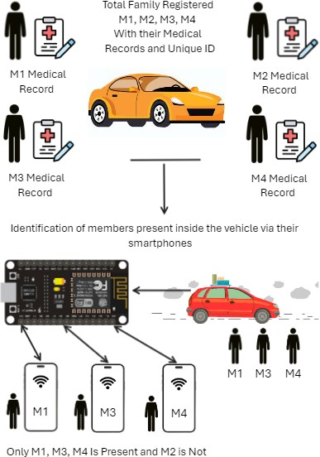

Figure (1): Identification of members sitting inside the vehicle using esp8266.

- GPS free location determination:
The use of a Geo-location API offers a GPS free method for pinpointing the vehicle’s location. This addresses the limitations of traditional GPS systems, ensuring accurate location data even in challenging environments. According to the provided study [12], Geo-location is based on a positioning algorithm that estimates a mobile terminal’s (MT) location coordinates by analyzing metrics reported by location sensing devices.
The GPS free approach is rooted in overcoming the specific limitations of consumer grade GPS in urban environments. While GPS is functional, its performance in 'urban canyons' characterized by signal multipath reflection and blockage leads to prolonged Time To First Fix (TTFF) and location inaccuracies that can exceed 20 meters. For emergency response, this delay and imprecision are critical drawbacks. A dedicated GPS module and its antenna represent a single point of failure. they are vulnerable to physical damage (for example antenna detachment or crushing), electromagnetic interference from damaged vehicle electronics, or requiring a slow cold start if vehicle power is lost. Our system strategically bypasses these issues as this device uses the dense urban infrastructure of Wi-Fi access points and cell towers, which are not susceptible to satellite line of sight problems. This results in a faster, more reliable, and often more accurate location fix precisely in the dense urban settings where a majority of vehicular accidents occur, making it a more affordable choice than a conventional GPS module for this application.
- Realtime hospital information retrieval:
Realtime retrieval of the names, directions, and contact details of the three closest hospitals is made possible by the integration of two excel sheets one for hospital details and the other for accident data storage. The device easily connects with Google Places API to fetch nearby hospitals from current coordinates, improving emergency services responsiveness and giving hospitals access to needed information.
- Automated communication:
The device’s ability to initiate HTTPs requests, coupled with the esp8266’s communication capabilities, ease the communication process. Automated email alerts via SMTP to both family members and medical facilities ensure that pertinent information, including the victim’s medical history and precise location, reaches the relevant authority promptly.
It is built upon the esp8266 hardware and employing an integrated approach to location determination, and communication, represents advancement in emergency response systems. This paper will further detail the design, implementation, and evaluation of the device.
IV. Methodology
Figure (2) illustrates the device working overview at the accident site. This device can easily be embedded with the car as it is just 4x2 cm in size and weighs nearly 20 grams, also it is attached to a lithium ion chargeable battery. If the car battery stops during a high impact accident, then it can also operate by itself which makes this device’s design cost as low as $2 with a processing time of less then 2 minutes.
- Hardware components and connectivity:
- Esp8266 integration: The heart of our device lies in the esp8266, a versatile and cost effective Wi-Fi module. This hardware component serves as the central hub for data processing and communication. It connects to smart phones by intelligently detecting and linking to their hotspots, allowing interaction without the need for user intervention by using family smart phone SSID and password.
The complete pseudo code to demonstrate the esp8266 integration to identify the family member and medical history retrieval from their unique identifier is shown in Algorithm I.

Algorithm I - Member identification and medical history retrieval
Input: Mi = {M1, M2, M3… Mn}, All Family Member’s smart phone Wi-Fi Credentials (ssid, password).
Registered Medical History unique ID: (MH) = { MH1, MH2, MH3… MHn}
MH = {Name, Age, Gender, Contact number, Link to medical history}
Output: Identified Member M1, M2…. Mm where member present (m) <= member registered (n)
begin
for Mi in {M1, M2, M3… Mn} do
if connect_to_wifi(Mi.ssid, Mi.password) == true:
Mi.status = 1
retrieve_information_Mi(MH)
else:
Mi.status = 0
end
return: Identified number of members present and their health details
end
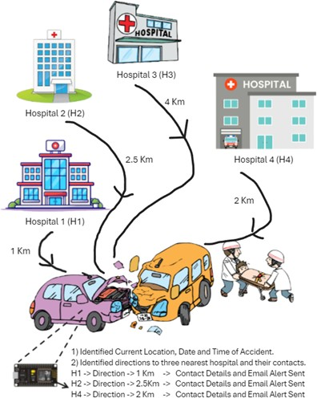

Figure (2): Detection of near by hospitals in range of 5 Km.

- Geo-location method using nearby cell towers or apps:
- Location determination: To pinpoint the vehicle’s location without relying on a conventional GPS module like neo-6m [13], our device employs a Geo-location method based on nearby cell towers or Access Points (APs). By using an API designed for this purpose, the device communicates with the surrounding cellular infrastructure and utilizes the Google Geo-location API to fetch the current location as shown in Algorithm II. This approach ensures reliable location data even in areas where GPS signals may be obstructed.
- It is important to distinguish the 'GPS free' nature of the device's hardware from its use of cloud based navigation services. The device itself lacks a GPS receiver. Instead, it transmits identifiers of nearby Wi-Fi access points and cell towers to the Google Geolocation API, which performs the triangulation on its servers and returns the coordinates. These coordinates are then used by the Google Maps and Places APIs, which are digital map and routing services, not GPS hardware to generate road level directions to the nearest hospitals. This approach make use of cloud infrastructure for complex geospatial computation that would be infeasible on the low cost ESP8266 module or Tensilica L106 core microchip.
Algorithm II - Current location detection using Geo-location API
Input: Geo_API = Google Geo-location API Credential.
Output:
- Nearby cell towers Tn = {mac address, signal strength, channel}. As shown in Figure (8).
- Current location coordinates latitude and longitude.
- Location accuracy in meters.
begin
set_clock( ): configure system time using NTP for synchronization.
for i=1 to 3 do
if internet_connected == true
response_json = https_get_location(Geo_API)
Map_link = https://www.google.com/maps/search/?api=1&query=coordinates
calculate accuracy in meters
break
else continue
end
return: Current location Map_link and accuracy
end
- Excel sheet’s structure and purpose:
- Hospital details sheet as a database (S1): One spreadsheet is dedicated to storing hospital details, including names, and contact information like emails, and phone numbers which cannot be accessed publicly by anyone. This structured database serves as a quick reference for the device during an emergency, ensuring that the three nearest hospitals can be contacted in an emergency as shown in Figure (3).
- Accident data sheet (S2): Another excel sheet is designed to capture and store accident information, such as date, time, location map, and directions to the three nearest hospitals as shown in Figure (4). This sheet acts as a dynamic repository that facilitates realtime communication with emergency responders, medical facilities, family members, and victims.
The complete pseudo code to demonstrate the spreadsheet communication between Hospital details sheet S1 and Accident data sheet S2 is shown in Algorithm III.

Algorithm III - Spreadsheet communication with each other to fetch and store contact details
Input:
- Spreadsheet 1 (S1) sheet_id = unique Spreadsheet id for database sheet.
- Spreadsheet 2 (S2) sheet_id = unique Spreadsheet id for accident data sheet.
- Value = current location latitude and longitude.
Output: Nearby hospitals directions and their contact details
begin
function get_nearby_hospitals_emails():
log parameters in JSON format.
set result to 'Ok'
if 'Value' parameter is missing:
set result to 'No Parameter named "value"'.
else:
set sheet_id, and new_Row in S2.
write timestamp and current location to S2.
get find_nearby_Hospitals(Value) Google Geo-Places API.and hospital_Emails from S1 if nearby_Hospitals has at least 3 hospitals:
for each hospital, write direction link and contact details from S1 to S2.
return hospital_Emails_Array.
function find_Nearby_Hospitals(Value):
set api key, radius range in meters, and url.
make API request, parse response.
if status is 'OK' and there are results:
sort results by hospital ratings, take first 3, directions to hospitals.
return: List of all nearby hospitals within radius range.
else:
return 'Error: Unable to find nearby hospitals'.
continue get_nearby_hospitals_emails():
end
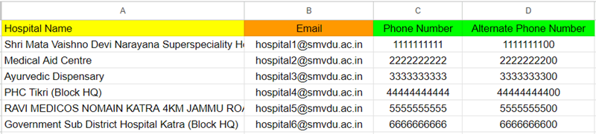
Figure (3): Hospital details sheet: storing hospital contact details.

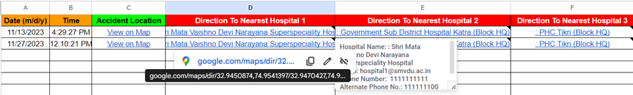
Figure (4): Accident data sheet: storing live accident location and directions to nearby hospitals with their contact details fetched from hospital details sheet.
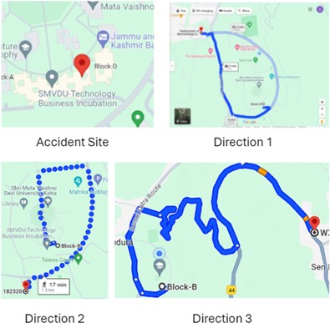

Figure (5): Showing accident location and directions to 3 nearest hospitals.
- HTTPS requests for information retrieval and storage:
- Hospital information retrieval: When an accident occurs, the device initiates an HTTPS request to the excel sheet storing accident data. This sheet then triggers an HTTPS request to the Google places API, fetching the names, directions, and contact details of the three nearest hospitals based on the accident location. Here, accident location and directions to 3 nearest hospitals are shown in Figure (5). The obtained information is saved in the excel sheet for reference.
- Accident data storage: Subsequently, the esp8266 sends an HTTPS request to the same excel sheet storing accident data, facilitating the storage of updated accident details, including date, time, and location. This information is critical for coordinating emergency responses and ensuring accurate and up to date records.
- The distance between accident coordinates and list of hospitals coordinates was computed using the Haversine formula [25], which calculates the great circle distance between two points on a sphere given their longitudes and latitudes.
- Email communication using SMTP:
- Automated email alert process: In the event of an accident, the esp8266 initiates an email alert process to notify nearby hospitals, including family members and medical facilities. The device employs the Simple Mail Transfer Protocol (SMTP) to facilitate seamless and secure email communication [15].
- Email content: The email content includes critical information’s such as the names and unique URLs of family members, the victim’s medical history, the link to the excel sheet containing accident details, and the precise location of the incident. This comprehensive email ensures that both family members and medical facilities receive detailed information immediately without any acknowledgement, Algorithm IV represents the psedo code for the approach presented above.
Algorithm IV - Email Alert to all family members and 3 nearby hospitals
Input:
- SMTP host name (SMTP_HOST) = smtp.gmail.com
- SMTP port (SMTP_PORT) = esp_mail_smtp_port_587
- Author's email (AUTHOR_EMAIL) = esp.snahal@gmail.com
- Author's password (AUTHOR_PASSWORD)
- Sender's name (constant value: "NEED ATTENTION")
- Email subject (constant value: "YOUR FAMILY NEEDS URGENT AMBULANCE")
- Recipients and message:
- "Member 1" (email: "member1@gmail.com") (Medical History 1)
- "Member 2" (email: "member2@gmail.com") (Medical History 2)
- "Member n" (email: "membern@gmail.com") (Medical History n)
- Hospitals Emails (using Hospital_EMAILS array from Algorithm III)
Output: Email alert sent to all the respective hospitals and family members
begin
function send_Mailto_Member():
set flag_Error to false
set stop_Check_Count to 3
do:
if stop_Check_Count is 0, print "Problem Sending E-Mail" and return
call network_Refresh() and Mail_Client.network_Reconnect(true)
set smtp debugging to true
declare and set all input and SMTP_Message (message)
set message details (sender, subject, recipients, HTML content, etc.)
if not smtp.connect(input), print connection error,
set flag_Error to true
decrement stop_Check_Count
continue
else
clear sending result log email_sent = true
disconnect from WiFi
return Email Sent
while email_sent != true
end

Figure (6): Email alert received at 12:10 PM with all required members details and links.

In Figure (4) you can see the accident time is 12:10:21 PM on 11/27/2023 and the email alert received time in Figure (6) is 12:10 PM which signifies the response time of the device.
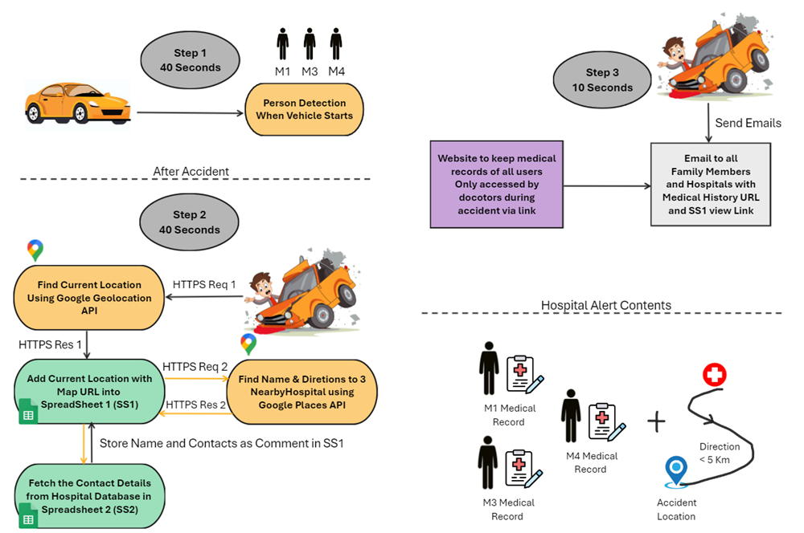
Figure (7): High level Flow chart of device working and contents of email alert.

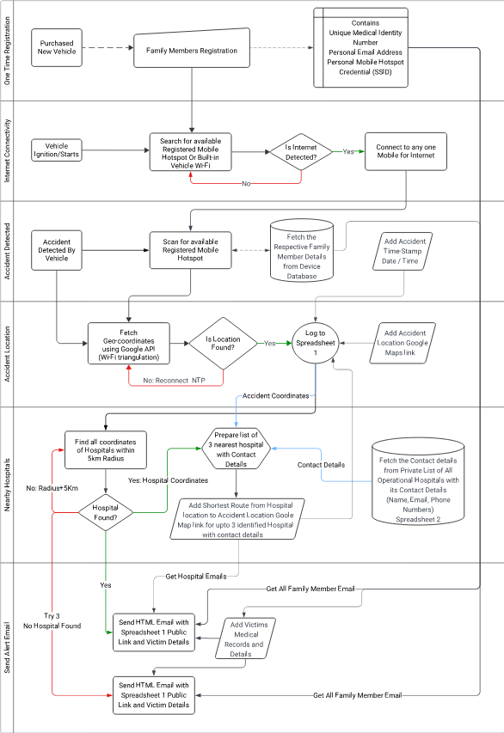
Figure (8): Detailed Flow chart of device working.

V. Results: implementations and discussion
A. Hardware Implementation
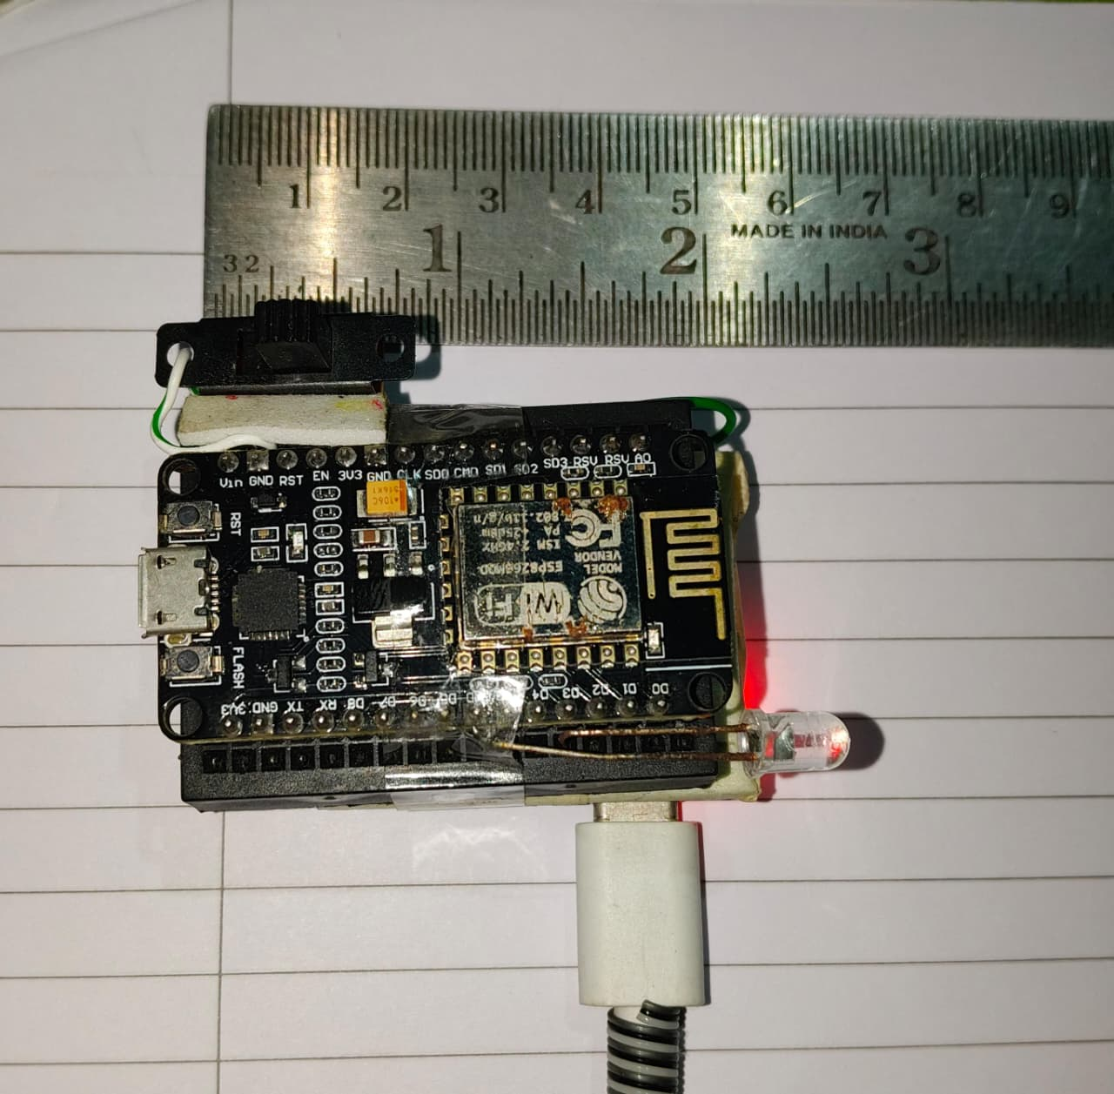
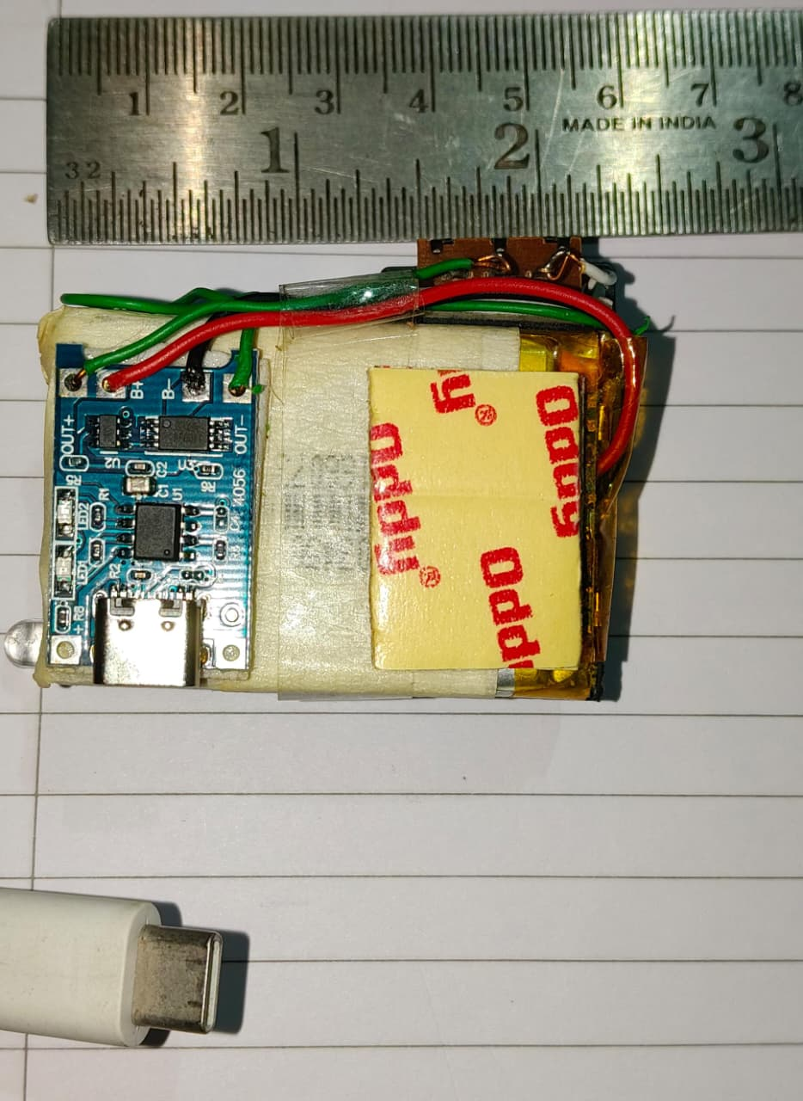
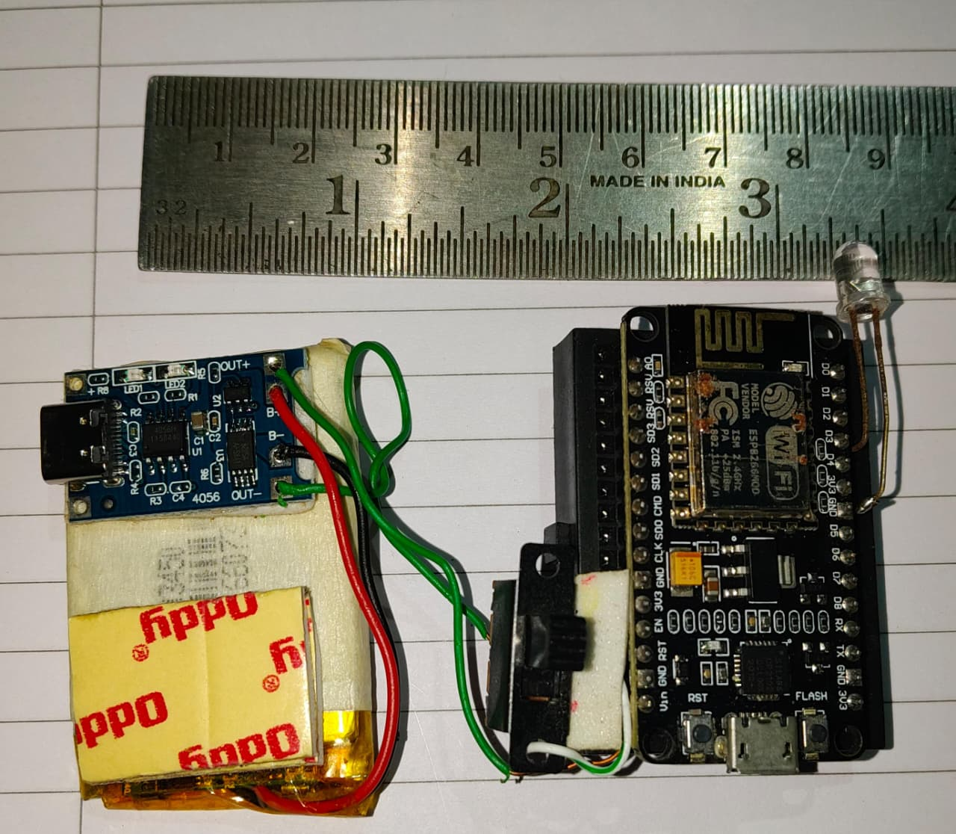

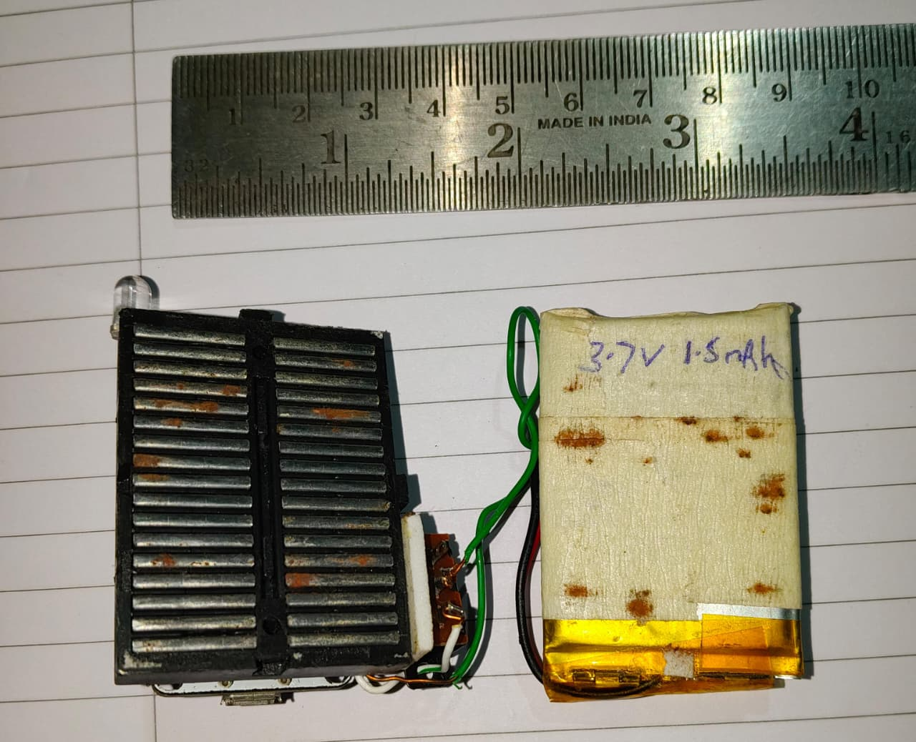
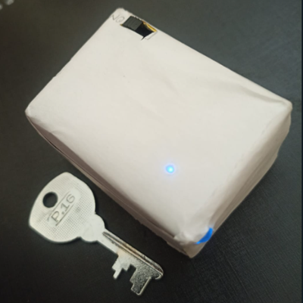
Figure (9): Prototype Hardware Images

Figure(9) This image shows the assembled prototype of the proposed device. Key components visible include:
- Manual Trigger Switch: Used in this prototype to simulate an accident event for testing and validation purposes.
- ESP8266 Microcontroller (ESP 12F Module): The core processing and communication unit of the system.
- Status LED: Provides visual feedback on the device's operational state.
- C type Charging & Protection Circuit (TP4056): Manages the charging and safety of the integrated 3.7V Li-Ion battery, allowing for standalone operation.
Note: In a production vehicle, the manual switch would be replaced by an automated trigger integrated with the vehicle's sensors (for example airbag control unit or an internal accelerometer), and the external charging port would be superseded by direct power integration from the vehicle's electrical system. This prototype validates the core logic and communication chain.

Table 6: Prototype Electrical Specifications and Battery Life Estimation.

Parameter | Specification / Measurement | Notes / Calculation
Microcontroller | ESP8266 (ESP-12F Module) | Core processing and Wi-Fi communication.
Power Supply | 3.7V Nominal Li-Ion Battery | Standard single-cell chemistry.
Battery Capacity | 1500 mAh | Determines total available energy.
Charging Circuit | TP4056 Type C Module | Provides safe charging and battery protection.
Current Draw (Sleep Mode) | ~70 µA | Deep sleep mode, device waiting for trigger.
Current Draw (Active Mode) | ~80 mA | Average during Wi-Fi transmission & processing.
Peak Current (Wi-Fi Tx) | Up to 170 mA | Short bursts during high power transmission.
Single Operation Duration | 90 seconds | Measured average from activation to system shutdown.
Energy per Operation | ~3.33 mAh | Calculation: (80 mA * 90 s) / 3600 s/h = 2 mAh. + Buffer for peaks ≈ 3.33 mAh.
Estimated Operations per Full Charge | ~450 cycles | Calculation: 1500 mAh / 3.33 mAh per cycle ≈ 450 cycles.
Estimated Standby Time | > 2.4 years | Calculation: Given:  Current in sleep = 70 µA = 0.07 mA  Battery = 1500 mAh  1500 ÷ 0.07 = 21428.57 hours  21428.57 ÷ 24 = 892.86 days ≈ 2.44 years

As detailed in Table 6, the device is highly power efficient. Its quiescent current in sleep mode is minimal (~70 µA), allowing for extended standby periods of over two years on a single charge. During an active accident response sequence, which we have measured to take approximately 90 seconds, the average current draw is 80 mA. This results in a very low energy consumption of only about 3.33 mAh per accident event.
This high efficiency translates directly into high reliability. From a full charge, the device can theoretically execute over 450 complete accident response cycles. This substantial operational buffer far exceeds any realistic scenario, ensuring the device remains functional even if the vehicle's main battery is disconnected and the device must rely solely on its internal power for multiple triggering events or a prolonged period between charges.

Table 7: Optimized Hardware Profile for Vehicular Integration Real World Power Management
Parameter | Prototype Specification | Optimized Production Version | Benefit of Optimization
Core Component | ESP8266 (ESP 12F Module) | ESP8266 SoC (System on Chip) | Removes PCB, pins, and shielding of the module, enabling a fully custom, miniature design.
Additional Components | TP4056 Charger, 3mm LED, Headers | Integrated Power Management IC (PMIC), 01005 LED | PMIC handles charging & regulation, tiny LED reduces footprint. All components are surface mounted.
Form Factor | Custom PCB (~4x2 cm) | Custom Ultra Compact PCB (~2x1 cm) | 75% reduction in size. Can be embedded within the vehicle's fuse box or dashboard seamlessly.
Power Source | 1500mAh Li-Ion Battery | 500-800 mAh Li-Ion Battery | The reduced size requires a smaller battery. Since the vehicle's main system is the primary power source, a smaller backup is sufficient for its fail safe role.
Integration | Standalone Device | Fully Integrated into Vehicle's ECU or Power Network | No external casing needed. Draws power directly from the car's system and uses the vehicle's ground.
Estimated BOM Cost | ~$8 (Prototype) | ~$2-4 (Mass Production >10k units) | 60-75% cost reduction due to component optimization and volume pricing.
Google Cloud Cost | 6000 Free API calls per minute means 6000 Accident per Minute | $2 per extra 1,000 Accident requests | Massive national scale deployment capability. Cost remains predictable and linear even under extreme load.
Key Advantage | Functional Prototype | Minimalist, Cost Effective, Automotive Grade Solution | Drastically reduces the Bill of Materials (BOM) and physical footprint, making mass production and adoption feasible.

For mass production and seamless vehicle integration, the hardware can be optimized both in size and cost. The prototype's ESP8266 module can be replaced by the core ESP8266 SoC itself, soldered directly onto a custom designed PCB. This, along with miniature surface mount components and a smaller backup battery, allows the entire system to be shrunk to an estimated 2x1 cm footprint a 75% size reduction. This optimization dramatically reduces the Bill of Materials (BOM) cost. While the prototype costs approximately $8, the production version is estimated at just $2-4 in volume manufacturing, making it one of the most cost effective accident response solutions proposed. This combination of minimal form factor and radical cost reduction is for widespread automotive adoption

Figure (7) Shows the device working in steps by representing it in flow chart and Figure (9), Figure (10) and Figure (11) show the result of each step respectively shown on the serial monitor of Arduino IDE. In Figure (7) step 1, Figure (9) shows the name of identified members present inside the vehicle. In Figure (7) step 2, Figure (10) shows about the current location via Geo-location API cloud service and uploads all the details to accident data sheet by communicating further with spreadsheet as demonstrated in Algorithm III, Figure (7) step 3, Figure (12) shows that the email has been sent to all the family members and hospitals using smtp protocol. The testing and simulation phases generated a dataset comprising different accident scenarios, each with unique parameters, such as location, time, and medical history. This dataset will be instrumental in further refining the device’s algorithms, optimizing its performance, and validating it in a real world conditions. In Figure (11), the device shows its error recovery process, if it fails to fetch or upload details to a spreadsheet then it will retry it which improves its error response. The device hardly takes 30 seconds after storing the data in a spreadsheet and sending an email to all the family members registered with the vehicle and 3 nearest hospitals, which reduces the response time.



Figure (9): Serial monitor showing member identification present in vehicle.

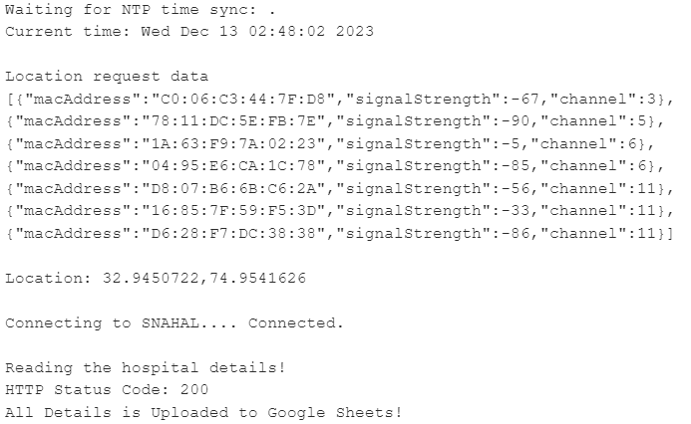

Figure (10): Serial monitor showing the current location and uploading all the details to accident datasheet (S2).
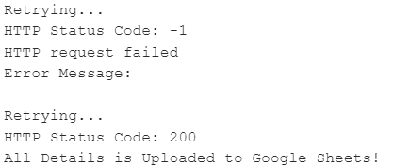
Figure (11): Serial monitor error handling of the device.
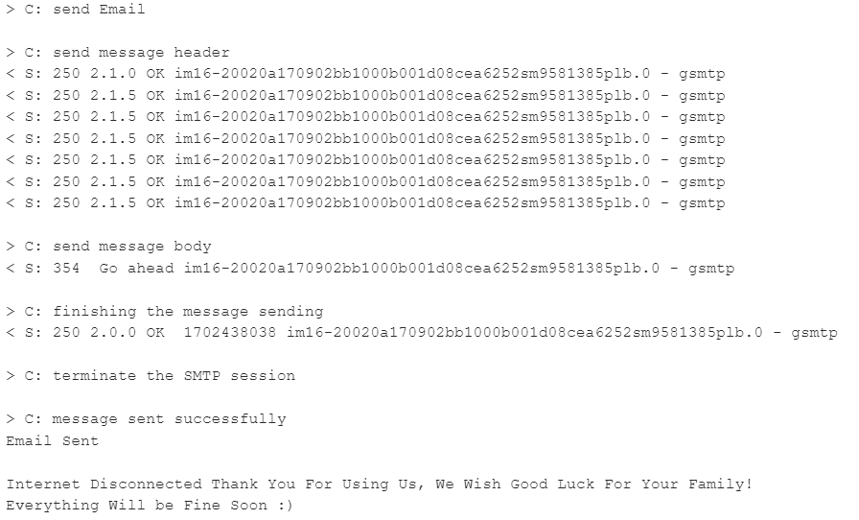
Figure (12): Serial monitor sending email alert.

B. Field Testing and Performance Validation
To evaluate the real world working of the proposed system, field testing was conducted across four major Indian cities Jammu, Ahmedabad, Mumbai, and Pune representing diverse geographical and urban environments. The device was subjected to different challenging scenarios to assess its performance under different conditions:
Test Environments Included:
- Urban Dense Areas: High rise buildings and dense residential societies in Mumbai and Pune
- Mixed Terrains: Varied topography in Jammu including hilly regions
- Network Challenged Zones: Underground parking facilities, multi level basements, and areas with poor cellular coverage
- Complex Infrastructure: Locations under bridges, tunnels, and densely populated market areas
- Standard Conditions: Open areas with clear network connectivity for baseline performance measurement
- Bad Rainy Weather: Tested in cloudy bad weather under heavy rain that degrades the satellite visibility.
The system demonstrated consistent performance across all test locations, with the following average metrics.
- Person Detection Phase: maximum time is 7 second for each person in the family if no member detected and minimum time to scan if all the person is present is less than 4 second each member via Wi-Fi hotspot scanning). If two person available out of 4 registered member than time observed is 25.2 ± 3.6 second.
- Location Acquisition: 3.2 ± 1.4 seconds (using Google Geolocation API) with 3 Retries adding 2 extra second delay to reconnect to NTP.
- Accident Logging & Hospital Integration: 26.3 ± 9.3 seconds (combined spreadsheet logging and hospital contact and route retrieval)
- No Hospital found Scenario: 6 second for failed response + 3 Retries with +5Km Radius upto 15Km Radius. Total time 6 + 6 + 6 ± 3 for no hospital detected in all 3 retries.
- Communication Phase: 20.6 ± 11.2 seconds (SMTP email delivery to multiple recipients) with 3 retries with adding 2 extra second delay to reconnect to NTP. 97% of success achieved on email delivery. With 3 retries each retries take additional 15 seconds.

Key Observations from Multi City Testing:
- In dense urban environments (Mumbai, Pune), the GPS free geolocation method consistently outperformed traditional GPS, providing faster location with 2-3 meter of accuracy in areas with limited satellite visibility and in heavy raining weather.
- The system demonstrated degradation in network challenged areas. While location accuracy varied by 15-20 meters based on limited available Wi-Fi/cellular post, the system maintained functionality across all test scenarios.
- Performance variations were primarily observed in location acquisition times, which correlated with local network density. Dense urban areas showed faster location fixes (17.8-2.4 seconds) compared to suburban/rural locations with less hospitable availability.(40.5-11.2 seconds).
- System Reliability: Across 40+ test scenarios spanning four cities, the system maintained 96% of success rate, with failures primarily occurring in complete network blackout situations (underground parking without any connectivity and inside running train under Tunnel).

The field validation confirms that the proposed system delivers reliable emergency response capabilities across diverse real world conditions, with consistent under 2 minute response times in connected environments and in challenging urban scenarios where traditional GPS based systems often fail.

C. Limitations and Challenges for Real World Deployment
While the proposed approach demonstrates high performance in controlled tests and diverse field environments, several limitations and challenges must be considered for widespread real world deployment:
- The core functionality of the device is contingent upon a stable internet connection to access Google Cloud APIs (Geolocation, Places, Sheets, SMTP). In remote areas with no cellular coverage or during widespread network outages, the system's ability to report an accident is compromised. While the internal battery ensures power availability, it cannot compensate for a lack of data connectivity.
- Current prototype uses a manual trigger to create accident scenario. For full autonomy, the system requires integration with a vehicle's internal network, for example CAN bus to access reliable crash detection signals from airbag sensors or accelerometers. This integration poses technical and standardization challenges across different vehicle manufacturers and models.
- Device handles sensitive personal health information (PHI) and location data. The current prototype uses standard HTTPS for security, but a production system would require end to end encryption of medical records and strict compliance with data protection regulations like GDPR and India's Digital Personal Data Protection Act.
- Device effectiveness depends on users pre registering their medical records and Wi-Fi credentials. The accuracy of the hospital database must be actively maintained. Any inaccuracies or outdated information in this database could lead to misdirection during an emergency.
- Person detection relies on the presence and connectivity of smartphones with Wi-Fi enabled. In a severe accident, phones could be damaged, powered off, or thrown from the occupants, leading to false negatives in occupant identification.
- The system automates alerting, but it cannot guarantee that the receiving hospitals have the protocols or infrastructure to automatically process these digital alerts and dispatch assistance without human intervention, potentially introducing a delay.
Addressing these limitations presents clear pathways for future work, including the development of offline caching mechanisms, standardized vehicle interface modules, enhanced encryption protocols, and partnerships with healthcare providers to ensure the received data integrates seamlessly into emergency response workflows.

VI. Future roadmaps
While the device has showcased its functionality, there are opportunities for refinement and enhancement in future:
- Enhanced medical record security: Implementing additional encryption measures for medical records in mHealth [10] can further enhance the security of sensitive information during communication.
- Machine learning integration: Exploring machine learning algorithms for predictive accident analysis [16], [17] and optimized hospital recommendations could enhance the device’s responsiveness and adaptability.
- User interface for emergency responders [18]: Developing a user interface tailored for emergency responders to visualize accident data and medical information in real time can streamline onsite decision making.
- Public awareness campaigns: Conducting public awareness campaigns to promote the adoption of the device and educate communities about its benefits can contribute to widespread acceptance and utilization.
- Device working without internet: After several advancements the device can store the location information and nearby hospital direction periodically in spreadsheet whenever it connects with internet and during accident if the internet is not available then the last saved data can be utilized for emergency response.
Currently this device can handle around 6000 accidents every minute by utilizing free service provided by Google Cloud. Further by increasing the response limit of Google Cloud it can handle infinite number of accidents which improves the quality of emergency service in wide range of area where current location and nearby authorities’ identification is required. As the device progresses from the research and development phase to real world deployment, the strategic collaborations will further amplify its role in saving lives and minimizing the impact of delayed assistance during vehicular accidents.
VII. Conclusion
Development and testing of the proposed device for efficient assistance during vehicle accidents have yielded multiple findings, pointing towards a transformative solution in the field of emergency response systems. The significance of this device lies in its ability to revolutionize the landscape of emergency response systems by addressing the identified challenges. The device offers a solution that combines hardware ingenuity, advanced Google API, real time data retrieval, and secure communication. Its cost effectiveness further enhances its accessibility and potential impact, particularly in scenarios where traditional systems may fall short.

Declarations:
Ethical Approval: Ethical approval is not applicable for this article.
Conflict of Interest: The authors declare that they have no competing interests.
Authors' contributions: All authors are the main authors of the current paper. They contributed to the development of the ideas, design of the study, theory, results analysis, and paper writing, and finally reading and approving the final manuscript.
Funding: Not Applicable.
Availability of Data: Data will be made available on reasonable request.
REFERENCES
- Global status report on road safety 2018: summary. Geneva: World Health Organization; 2018 (WHO/NMH/NVI/18.20). License: CC BYNC-SA 3.0 IGO.
- J. Pedestrian a road safety manual for decision-makers and practitioners, second edition. Geneva: World Health Organization. 2023. Licence: CC BY-NC-SA 3.0 IGO
- N. Gadkari, “Road Accidents in India 2021,” Government of India Ministry of Road Transport and Highways Transport Research Wing New Delhi, pp. 121-149, Dec. 2022.
- M. S. Amin, J. Jalil and M. B. I. Reaz, “Accident detection and reporting system using GPS, GPRS and GSM technology,” International Conference on Informatics, Electronics & Vision (ICIEV), Dhaka, Bangladesh, pp. 640-643, 2012, doi: 10.1109/ICIEV.2012.6317382.
- H. D. Pham, M. Drieberg and C. C. Nguyen, “Development of vehicle tracking system using GPS and GSM modem,” IEEE Conference on Open Systems (ICOS), Kuching, Malaysia, pp. 89-94 2013, doi: 10.1109/ICOS.2013.6735054.
- A. Abhiram, S. H. Basha, S. A. Balakrishnan and D. S. P, “Design of GPS Antenna for Vehicular Application,” 4th International Conference on Signal Processing and Communication (ICSPC), Coimbatore, India, pp. 148-152, 2023, doi: 10.1109/ICSPC57692.2023.10125699.
- E. Larsson, M. a´rtensson, N. Alexanderson, “First-aid Training and Bystander Actions at Traffic Crashes,” A Population Study. Pre hospital and Disaster Medicine pp 17(3), 134-141., 2002 doi:10.1017/S1049023X00000352.
- Z. Liu and C. Wang, “Design of Traffic Emergency Response System Based on Internet of Things and Data Mining in Emergencies,” IEEE Access, vol. 7, pp. 113950-113962, 2019, doi: 10.1109/ACCESS.2019.2934979.
- P. Fischer, J. I. Krueger, T. Greitemeyer, C. Vogrincic, A. Kastenmuller, D. Frey, M. Heene, M. Wicher and M. Kainbacher, “The bystander-effect: A meta-analytic review on bystander intervention in dangerous and non-dangerous emergencies,” Psychological Bulletin, pp 137(4), 517–537, Jul. 2011, PMID: 21534650 doi: 10.1037/a0023304.
- B. J. Philip, M. Abdelrazek, S. Barnett, A. Bonti and J. Grundy, “Toward a Unified mHealth Platform: A Survey of Current User Challenges and Expectations,” IEEE Access, vol. 11, pp. 19876-19891, 2023, doi: 10.1109/ACCESS.2023.3249786.
- O. Hara, Rachel, et al., “A qualitative study of decision-making and safety in ambulance service transitions,” NIHR Journals Library, December 2014. doi:10.3310/hsdr02560K.
- K. Pahlavan, Xinrong Li, and J. P. Makela. 2002. Indoor geolocation science and technology. Comm. Mag. 40, 2 (February 2002), 112–118. doi: 10.1109/35.983917.
- A. M. Luthfi, N. Karna and R. Mayasari, “Google Maps API Implementation On IOT Platform for Tracking an Object Using GPS,” IEEE Asia Pacific Conference on Wireless and Mobile (APWiMob), Bali, Indonesia, pp. 126-131, 2019, doi: 10.1109/APWiMob48441.2019.8964139.
- M. S. A. Malik and S. Sulaiman, “Doctor’s perspective for use of EHR visualization systems in public hospitals,” 2013 Science and Information Conference, London, UK, 2013, pp. 86-92.
- R. Sureswaran, H. A. Bazar, O. Abouabdalla, A. M. Manasrah and H. El-Taj, “Active e-mail system SMTP protocol monitoring algorithm,” 2nd IEEE International Conference on Broadband Network & Multimedia Technology, Beijing, China, pp. 257-260, Oct. 2009 doi:10.1109/ ICBNMT.2009.5348490.
- M. F. Labib, A. S. Rifat, M. M. Hossain, A. K. Das and F. Nawrine, “Road Accident Analysis and Prediction of Accident Severity by Using Machine Learning in Bangladesh,” 2019 7th International Conference on Smart Computing & Communications (ICSCC), Sarawak, Malaysia, 2019, pp. 1-5, doi: 10.1109/ICSCC.2019.8843640.
- J. Patil, M. Prabhu, D. Walavalkar and V. B. Lobo, “Road Accident Analysis using Machine Learning,” 2020 IEEE Pune Section InterNational Conference (PuneCon), Pune, India, 2020, pp. 108-112, doi: 10.1109/PuneCon50868.2020.9362403.
- G. Erik, Nilsson and K. Stølen., “Generic functionality in user interfaces for emergency response,” In Proceedings of the 23rd Australian Computer-Human Interaction Conference (OzCHI ’11). Association for Computing Machinery, New York, NY, USA, 233–242. Nov. 2011 doi: 10.1145/2071536.2071574
- Alkhaiwani AH, Alsamani BS, “A Framework and IoT-Based Accident Detection System to Securely Report an Accident and the Driver’s Private Information,” Sustainability, May. 2023; 15(10):8314. doi: 10.3390/su15108314
- Li. Baode, Lu. Jing, Lu. Han and Li. Jing, “Predicting maritime accident consequence scenarios for emergency response decisions using optimization-based decision tree approach,” Maritime Policy & Management, Taylor & Francis Journals, vol. 50(1), pages 19-41, Jan. 2023 doi: 10.1080/03088839.2021.1959074
- A. Chaudhari, H. Agrawal, S. Poddar, K. Talele and M. Bansode, “Smart Accident Detection and Alert System,” IEEE India Council International Subsections Conference (INDISCON), NAGPUR, India, 2021, pp. 1-4, doi: 10.1109/INDISCON53343.2021.9582163.
- S. Karthikeyan, J. Kiruthik, S. Madumitha, R. Manikandan and V. Prakash Raj, “Design and Implementation of IoT Based Accident Detection and Prevention System,” 7th International Conference on Trends in Electronics and Informatics (ICOEI), Tirunelveli, India, 2023, pp. 412-419, doi: 10.1109/ICOEI56765.2023.10125826.
- H. Srivastava et al., “IoT-Based Road Accident Rescue System Implementation for Smart City Applications,” IEEE 2nd International Symposium on Sustainable Energy, Signal Processing and Cyber Security (iSSSC), India, 2022, pp. 1-6, doi: 10.1109/iSSSC56467.2022.10051547.
- Bhandare, Sujit N., Prashant R. Mule, Yogesh A. Yeole, Krushna D. More, and Suhas B. Khadake. "Vehicle Tracking And Accident Alert System." (2025): IJARSCT 234-252.
- Yunardi, E., Magdalena, L. and Febima, M., 2024. Implementation of the Haversine Formula Method in Geographic Information Systems for Searching the Nearest Sea Freight Expedition Services in East Jakarta. Journal of Artificial Intelligence and Engineering Applications (JAIEA), 4(1), pp.283-288.
- N. Gadkari, “Road Accidents in India 2023,” Government of India Ministry of Road Transport and Highways Transport Research Wing New Delhi. pp. 27-54.
- National Center for Statistics and Analysis. (2025, April). Overview of motor vehicle traffic crashes in 2023 (Traffic Safety Facts Research Note. Report No. DOT HS 813 705). National Highway Traffic Safety Administration. pp. 4-12.
- “Use Crash Detection on your iPhone or Apple Watch,” Apple Support. [Online]. Available: https://support.apple.com/en-in/104959. Published Date: September 25, 2025
- “Use Emergency SOS via satellite on your iPhone,” Apple Support. [Online]. Available: https://support.apple.com/en-in/101573. Published Date: September 23, 2025

